

Techno International New Town



**Applied Electronics & Instrumentation Engineering (AEIE)**



**Technical Report for final year project (BATCH: 2020-2021)**



**Project name : Automatic Fire Fighting Vehicle**

**Members :** Indrajit Mazumder (18705520010) Sourav Kumar Shaw (18705520015) Anurag Sarkar (18705520013)

Kankana Rakshit (18705520011)

Aditi Gupta (18705520016)

**Submission Date : 05/12/2023**



# CERTIFICATE

This is to certify that Indrajit Mazumder (18705520010), Sourav Kumar Shaw(18705520015), Anurag Sarkar (18705520013), Kankana Rakshit (180705520011) And Aditi Gupta (18705520016) of Department of Applied Electronics and Instrumentation Engineering, have completed their final year project on “Fire fighting vehicle” for the partial fulfillment of B.Tech course, session 2020-2021, Maulana Abul Kalam Azad University of Technology(MAKAUT), under my supervision.



Prof. Samrat Banerjee Project Guide Assistant Professor

Dept. Of Applied Electronics And Instrumentation Engineering

# ACKNOWLEDGEMENT

We would like to express our sincere gratitude and appreciation to all those who have contributed to the successful completion of this final year project. Their support and guidance have been invaluable throughout this journey.

First and foremost, we extend our deepest thanks to [Prof. Samrat Banerjee, Department of AEIE], our project supervisor, for their continuous support, guidance, and mentorship. Their expertise and constructive feedback have been instrumental in shaping this project and enhancing its quality.

We are also grateful to [Techno International New Town] for providing the necessary resources and facilities for the successful completion of this project. The conducive environment and access to [specific equipment, software, etc.] significantly contributed to the overall success of the project.

Also, we would like to thank Prof.(Dr.) R. T. Goswami (Director) for his extended support.

Lastly, we would like to thank all those who, directly or indirectly, contributed to this project. Your support has been essential in making this project a reality.

Thank you all for being a part of this journey.

Yours Sincerely,

Indrajit Mazumder (18705520010), Sourav Kumar Shaw (18705520015), Anurag Sarkar (18705520013), Kankana Rakshit (18705520011), Aditi Gupta (18705520016)

# CONTENTS

* Certificate……………………………………………………..
* Acknowledgement……………………………………………
* Contents………………………………………………………
* Abstract……………………………………………………….
* Introduction…………………………………………………...
* Project Description………………………………………........
* Requirements………………………………………
* Working Principle…………………………………………….
* Circuit Diagram……………………………………………....
* Code…………………………………………………………..
* Application……………………………………………………
* Problem statement…………………………………………….
  + Proposed Solution
* Future Scope………………………………………………….
* Conclusion……………………………………………………
* Reference……………………………………………………..

# ABSTRACT

Firefighting vehicles, the stalwarts of emergency response, are indispensable mechanisms wielded by firefighting professionals. They serve as mobile arsenals, laden with an array of specialised equipment and resources, all meticulously designed to quench the raging infernos that threaten our homes and lives. The pivotal role they play in safeguarding society underscores the importance of their continuous evolution. This project will delve into the intricate realm of firefighting vehicle design and development, shedding light on the myriad facets that contribute to their effectiveness. It will closely examine the latest technologies and innovations that are reshaping the landscape of firefighting logistics. From advancements in water pump systems that augment firefighting capabilities, to enhanced safety features that ensure the well-being of our brave firefighters, this exploration will encompass all aspects of these life-saving machines. The project not only aims to highlight the current state-of-the-art in firefighting vehicle technology but also aspires to stimulate thought and inspire further innovation in this crucial field.

# INTRODUCTION

Undoubtedly, fires pose a menacing threat to both life and property. Their unpredictable nature and devastating potential necessitate swift and efficient countermeasures to ensure public safety. Firefighting vehicles, commonly referred to as fire trucks or fire engines, form the vanguard in this fight against such calamities. These vehicles serve as more than just a mode of transportation for our brave firefighters. They are sophisticated, purpose-built machines equipped to handle a broad spectrum of firefighting tasks.

Specially engineered to accommodate vast amounts of water and firefighting foam, these vehicles are essentially mobile fire extinguishing units ready to spring into action at a moment's notice. They house a diverse arsenal of tools and equipment, from high-pressure hoses and ladders to cutting and prying tools, all designed to combat different types of fires and execute rescue operations.

Furthermore, the versatility of these vehicles extends beyond firefighting. They are often equipped with advanced life support equipment for emergency medical services, making them indispensable in a variety of crisis situations. Together, these functionalities underscore the pivotal role firefighting vehicles play in protecting our communities and highlight the importance of continuous innovation in their design and development.

# PROJECT DESCRIPTION

The Firefighting Vehicle Project aims to revolutionise emergency response by developing an intelligent, technologically advanced vehicle equipped with cutting-edge components. This vehicle is designed to enhance firefighting capabilities, providing a swift, efficient, and safe response to various fire scenarios.

Key Features and Components:

Intelligent Control System:

* Utilises Arduino Uno as the central control unit to integrate and coordinate all components seamlessly.
* Employs a user-friendly interface for intuitive control by firefighting personnel.

Enhanced Fire Detection:

* Incorporates three IR flame sensors for early and accurate fire detection.
* Enables the vehicle to respond rapidly to different fire intensities and types.

Agile Mobility and Navigation:

* Bo Motors, driven by the L298N Motor Driver, provide agile and precise movement.
* Designed to navigate challenging terrains, ensuring accessibility to fire incidents.

Optimised Water Dispensation:

* Utilises a water pump system with precise control mechanisms for efficient and targeted firefighting.
* Implements features such as pressure regulation and nozzle control for effective water deployment.

Robust Power Management:

* Features a 3.7V battery with a 10A 12V BMS to ensure reliable and sustained power supply.
* Prioritises power efficiency to extend operational periods during firefighting operations.

Automated Nozzle Control:

* Incorporates an SG90 Servo Motor for automated control of the water nozzle.
* Enhances precision and flexibility in directing water flow during firefighting operations.

Safety Measures:

* Implements fail-safe mechanisms to ensure the safety of firefighting personnel and the vehicle.
* Designs the vehicle with robust construction to withstand harsh firefighting conditions.

Scalable and Adaptable Design:

* Created with the potential for future upgrades and additions to adapt to emerging firefighting technologies.
* Balances cost-effectiveness and sustainability without compromising performance.

Real-world Testing and Validation:

* Rigorously tested under simulated firefighting scenarios to validate the vehicle's effectiveness and reliability.
* Gather feedback from firefighting professionals to refine and improve the vehicle's performance.

The Firefighting Vehicle Project represents a significant leap forward in firefighting technology, embodying innovation, efficiency, and safety in its design and functionality. This project is driven by the commitment to enhance emergency response capabilities, ultimately contributing to the safety and well-being of communities.

# REQUIREMENTS

## HARDWARE REQUIREMENTS : SOFTWARE REQUIREMENT :

* Arduino uno ● Arduino IDE (windows)
* Single channel Relay
* Motor driver L298N
* Bo motor (4x) with wheels
* Ir flame sensor(3x)
* Battery 3 x 3.7v
* Bms 10a 12v
* Water pump 5v
* Male to female wire
* Servo motor sg90
* Socket

## MISCELLANEOUS REQUIREMENTS :

* Glue gun
* Multimeter
* Charger

# COMPONENTS

## ARDUINO UNO :

Arduino is an open source computer hardware and software company, project, and user community that designs and manufactures single-board microcontroller and microcontroller kits for building digital devices and interactive objects that can sense and control objects in the physical and digital world. The project's products are distributed as open-source hardware and software, which are licensed under the GNU Lesser General Public License (LGPL) or the GNU General Public License(GPL), permitting the manufacture of Arduino boards and software distribution by anyone. Arduino boards are available commercially in preassembled form, or do-it-yourself (DIY) kits. Arduino board designs use a variety of microprocessors and controllers. The boards are equipped with sets of digital and analog input/output(I/O) pins that may be interfaced to various expansion boards or Breadboards(shields) and other circuits. The boards feature serial communications interfaces, including Universal Serial Bus (USB) on some models, which are also used for loading programs from personal computers. The microcontrollers are typically programmed using a dialect of features from the programming languages and C++. In addition to using traditional compiler toolchains, the Arduino Project Provides an integrated development environment (IDE) based on the Processing Language project. The Arduino project started in 2003 as a program for students at the Interaction Design Institute Ivrea in Ivrea, Italy, aiming to provide a low-cost and easy way for novices and professionals to create devices that interact with their environment using sensors and actuators. Common examples of such devices intended for beginner hobbyists include simple robots, thermostats, and motion detectors.

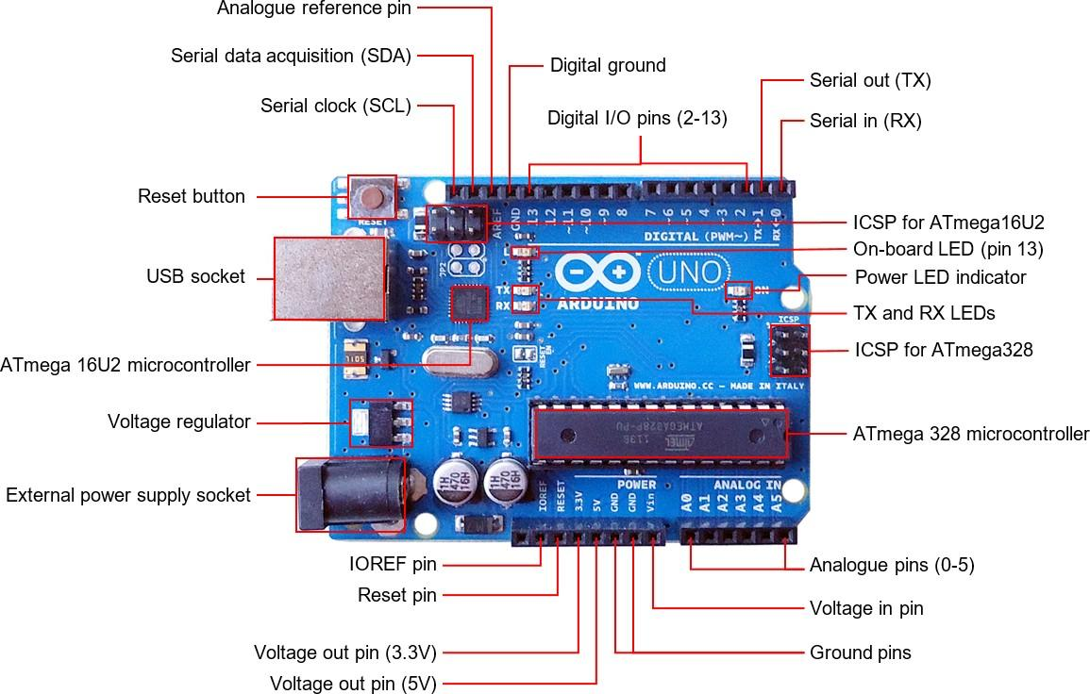

Features of the Arduino UNO :

* 1. Microcontroller: ATmega328
  2. Operating Voltage: 5V
  3. Input Voltage (recommended): 7-12V
  4. Input Voltage (limits): 6-20V
  5. Digital I/O Pins: 14 (of which 6 provide PWMoutput)
  6. Analog Input Pins: 6
  7. DC Current per I/O Pin: 40 mA
  8. DC Current for 3.3V Pin: 50 mA
  9. Flash Memory: 32 KB of which 0.5 KB used by bootloader
  10. SRAM: 2 KB (ATmega328)
  11. EEPROM: 1 KB (ATmega328)
  12. Clock Speed: 16 MH

## SINGLE CHANNEL RELAY :

A single-channel relay refers to a relay device that has a single switch or channel. In electronics, a relay is an electromechanical switch that is operated by an electric current. It consists of a coil and a set of contacts. When an electrical current is applied to the coil, it generates a magnetic field that causes the contacts to open or close, thereby allowing or interrupting the flow of electricity.

In the context of a single-channel relay:

1. Single Channel :
   * This indicates that the relay has only one switch or circuit. It can be in either an open or closed state, depending on whether the relay is energised (coil activated) or not.
2. Applications :
   * Single-channel relays find applications in various electronic and electrical systems where a simple on/off control is needed. For example, in home automation, a single-channel relay might be used to control the power to a single device, such as a light or a fan. It could also be used in industrial automation, electronic projects, or any other application where the activation of a single electrical circuit is required.
3. Control Logic :
   * The activation of the relay (closing the switch) is typically controlled by an external signal, such as a voltage or current. When the control signal reaches a certain threshold, the relay responds by changing its state.
4. Versatility :
   * While a single-channel relay is straightforward, it can be part of more complex systems when multiple relays are used together. For instance, in a relay module, several single-channel relays might be integrated into a single board, each controlling a different circuit.

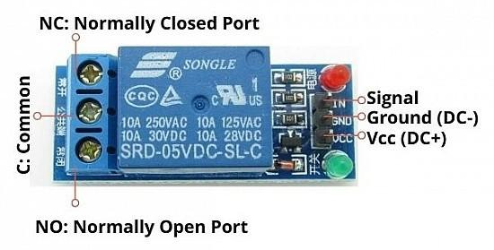

## MOTOR DRIVER L298N :

The L298N is a dual H-Bridge motor driver which allows speed and direction control of two DC motors at the same time. The module can drive DC motors that have voltages between 5 and 35V, with a peak current up to 2A. Let's take a closer look at the pinout of the L298N module and explain how it works.

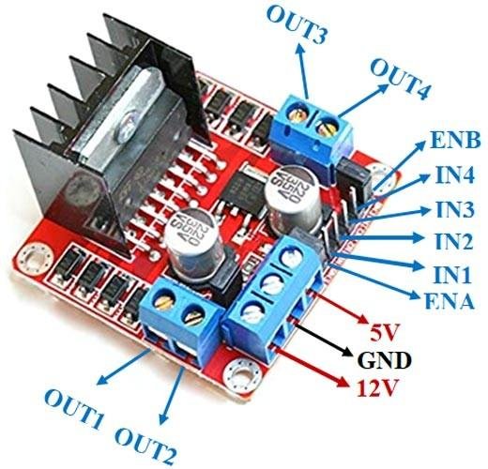

BO MOTOR 4x WITH WHEELS :

A BO motor is a lightweight, battery-operated DC geared motor. BO motors have good torque and RPM at lower voltages. They can run in both forward and reverse directions.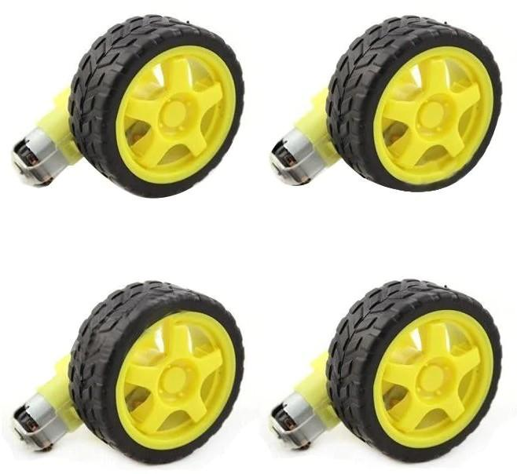

## IR FLAME SENSOR :

An IR (Infrared) flame sensor is a device that is designed to detect the presence of a flame or fire based on the infrared radiation emitted by the flames. It is commonly used in various applications, including fire detection systems and safety devices. The basic principle behind IR flame sensors is the detection of infrared radiation that is characteristic of flames.

Brief explanation of how IR flame sensors work:

1. Infrared Radiation Emission :
   * Flames emit infrared radiation as a part of their electromagnetic spectrum. This infrared radiation is not visible to the human eye but can be detected by specialised sensors.
2. Sensor Components :
   * An IR flame sensor typically consists of an infrared-sensitive photodiode or phototransistor. These components are sensitive to the specific wavelengths of infrared radiation emitted by flames.
3. Detection Mechanism :
   * When the sensor is exposed to the infrared radiation emitted by a flame, it generates a corresponding electrical signal. The intensity of the signal is proportional to the strength of the infrared radiation received.
4. Signal Processing :
   * The generated electrical signal is then processed by the sensor circuitry. This circuitry is designed to distinguish between the characteristic infrared signature of a flame and other sources of infrared radiation, such as sunlight or artificial lighting.
5. Output :
   * If the sensor detects a flame, it typically provides an output signal, which can be used to trigger an alarm, activate safety systems, or perform other predefined actions.

IR flame sensors are commonly used in various applications where rapid and reliable fire detection is crucial, such as in industrial settings, commercial buildings, and homes. They contribute to the early detection of fires, allowing for prompt response and minimising potential damage.

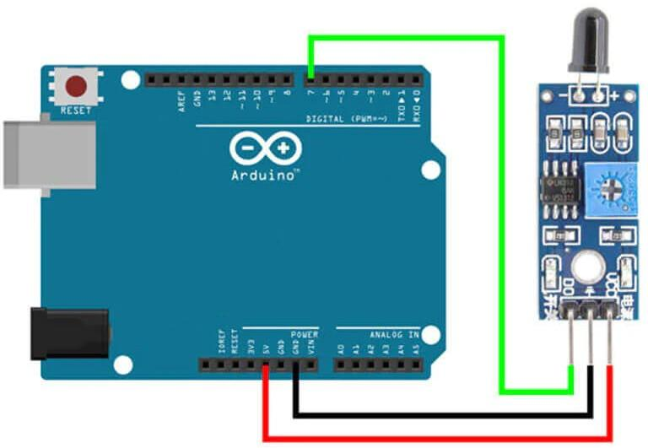

## SERVO MOTOR SG90 :

The SG90 is a popular and widely used micro servo motor. It is a small, lightweight device commonly employed in hobbyist and DIY projects. The SG90 servo motor is known for its affordability, ease of use, and versatility. Here are some key features and specifications of the SG90 servo motor:

1. Size :
   * The SG90 is a compact servo motor, making it suitable for applications where space is limited.
2. Torque :
   * It typically provides a torque of around 1.8 kg/cm, which is sufficient for many small-scale projects.
3. Speed :
   * The speed of the SG90 is around 0.1 seconds per 60 degrees rotation.
4. Voltage :
   * It operates on a voltage range of 4.8V to 6V, making it compatible with common power sources like AA batteries.
5. Control Signal :
   * The SG90 is a 3-wire device, with red and brown wires for power (VCC and GND) and a yellow wire for the control signal.
6. Rotation Range :
   * The servo motor can rotate approximately 180 degrees.
7. Applications :
   * It is often used in radio-controlled aeroplanes, cars, boats, robotics, and various other projects where precise and controlled movement is required.

When using the SG90 servo motor, it's important to note that it is not suitable for heavy-duty applications due to its limited torque. Additionally, accurate control can be achieved by sending a PWM signal to the control wire, allowing you to position the servo at different angles within its range.

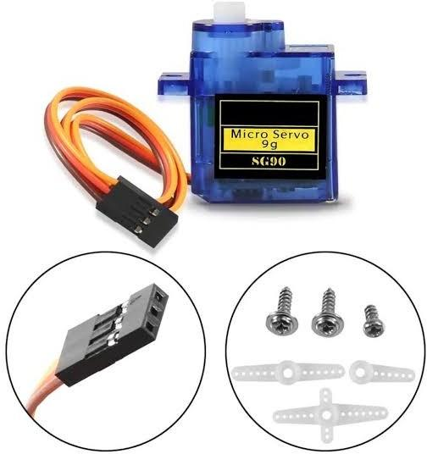

## WATER PUMP 5V :

A water pump that operates at 5 volts typically refers to a pump designed to be powered by a 5-volt power source. This voltage is common in low-power electronic devices and microcontroller-based projects. Water pumps are devices that move water from one place to another, and they come in various types and sizes depending on the specific application.

In the context of electronics and DIY projects, a 5V water pump is often used in scenarios where a low-voltage power supply is available or when interfacing

with microcontrollers like Arduino or Raspberry Pi, which commonly operate at 5 volts. These pumps are suitable for tasks such as circulating water in small aquariums, creating water fountains, or supplying water for specific cooling purposes in electronics.

It's essential to check the specifications of the water pump to ensure it matches the requirements of your project, including factors like flow rate, head pressure, and compatibility with the intended power source.

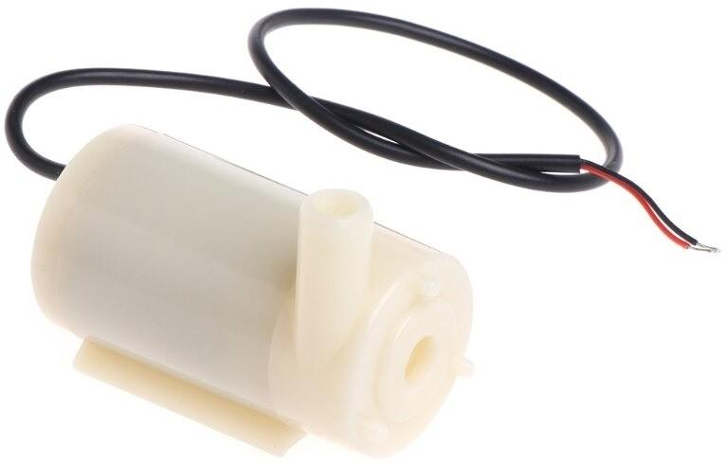

## BMS 10A 12V :

"BMS 10A 12V" likely refers to a Battery Management System (BMS) with a 10-ampere capacity designed for a 12-volt battery system.

A Battery Management System is an electronic system that manages and monitors the charging and discharging of rechargeable batteries. It helps ensure the battery operates within safe operating limits, prevents overcharging or over-discharging, balances the cells in a multi-cell battery pack, and provides other protective functions.

In the case of "BMS 10A 12V," it suggests that the BMS is capable of handling a maximum current of 10 amperes and is intended for use with a 12-volt battery. This information is commonly found on BMS specifications to help users select the appropriate BMS for their specific battery setup.

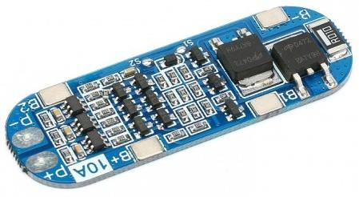

BATTERY 3 x 3.7V :

For example, almost all lithium polymer batteries are 3.7V or 4.2V batteries. What this means is that the maximum voltage of the cell is 4.2V and that the "nominal" (average) voltage is 3.7V. As the battery is used, the voltage will drop lower and lower until the minimum which is around 3.0V.

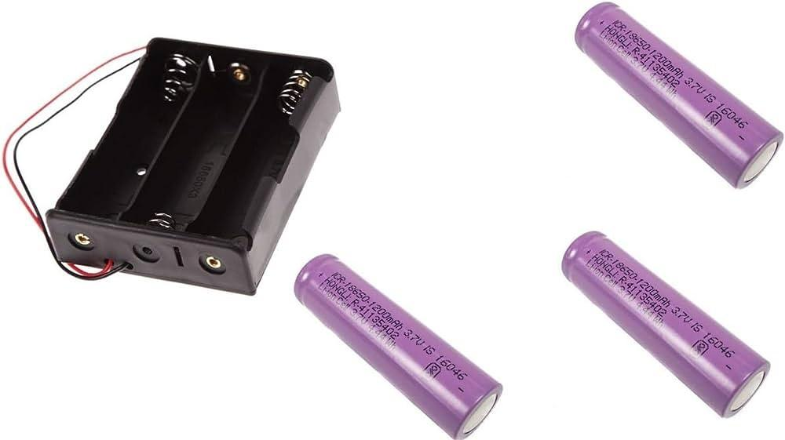

## MALE TO FEMALE WIRE :

Male to female jumper wires are used for easy and convenient interconnection between components in electronic prototyping and testing projects, without the need for soldering. They come in groups or cables with connectors or pins at each end and can connect FRC pins, Header pins, Berg pins, and other components.

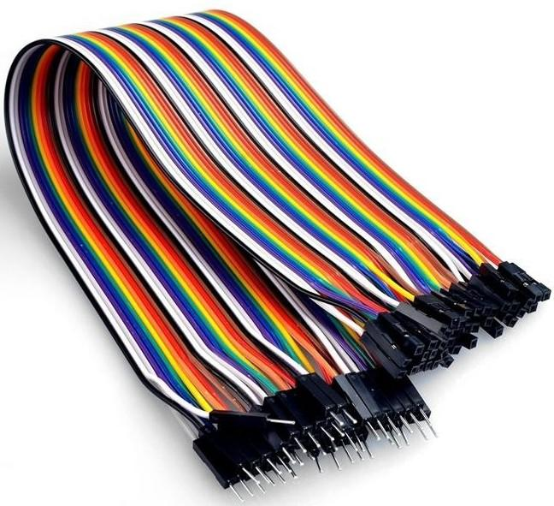

# WORKING PRINCIPLE

A firefighting vehicle, commonly known as a fire truck or fire engine, is a specialised vehicle designed for the purpose of firefighting and rescue operations. The working principle of a firefighting vehicle involves several key components and features:

1. Water Pumping System :
   * Fire trucks are equipped with powerful water pumping systems. The water can be sourced from a hydrant, water tank, or other water sources.
   * The pump pressurises the water and delivers it through hoses to the firefighting nozzle.
2. Water Tank :
   * Many firefighting vehicles have water tanks to carry a significant amount of water to the incident scene. This is useful when a hydrant is not readily available.
3. Hoses and Nozzles :
   * Hoses are used to transport water from the pump to the fire. They are typically made of a durable material to withstand high pressure.
   * Nozzles are attached to the hoses and allow firefighters to control the flow and pattern of water.
4. Foam System :
   * Some firefighting vehicles are equipped with foam systems that mix foam concentrate with water to create a foam solution. Foam is useful for suppressing flammable liquid fires and creating a barrier to prevent reignition.
5. Water Cannon or Monitor :
   * Water cannons or monitors are devices mounted on the top of the fire truck that can be remotely controlled to deliver a powerful stream of

water over long distances. They are useful for attacking fires from a safe distance.

1. Equipment Storage :
   * Fire trucks carry various firefighting tools and equipment, including hoses, nozzles, axes, ladders, breathing apparatus, and other rescue tools. These are stored in compartments for easy access.
2. Emergency Lighting and Siren :
   * Fire trucks are equipped with emergency lights and sirens to alert other motorists and pedestrians when responding to a call. This helps create a clear path for the vehicle.
3. Communication Systems :
   * Firefighting vehicles are equipped with communication systems to facilitate coordination among the crew and with other emergency services.
4. Specialized Vehicles :
   * Some fire departments have specialised vehicles for specific tasks, such as aerial ladder trucks for rescues from tall buildings or forest fire trucks for wildfires.
5. Crew Compartment :
   * Fire trucks have a crew compartment to transport firefighters to the incident scene safely.

The working principle revolves around the effective deployment of these components and the coordination of trained personnel to extinguish fires, perform rescues, and mitigate various emergency situations. The specific features and capabilities of firefighting vehicles may vary depending on the type of vehicle and the requirements of the fire department.

# CIRCUIT DIAGRAM

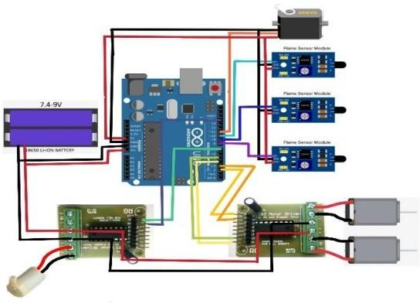

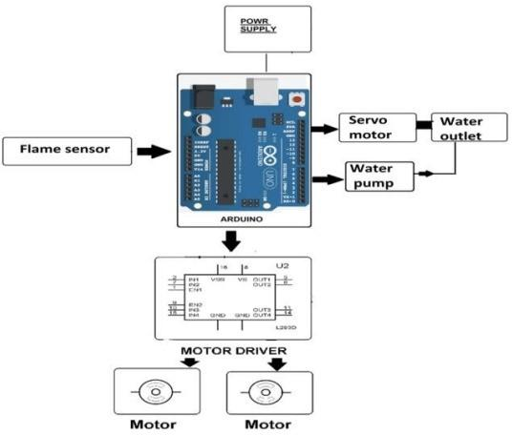

**CODE**

/*------ Arduino Fire Fighting Robot Code */

#include <Servo.h> Servo myservo;

int pos = 0;

boolean fire = false;

/-------defining Inputs /

#define Left_S 9 // left sensor #define Right_S 10 // right sensor #define Forward_S 8 //forward sensor

/-------defining Outputs /

#define LM1 2 // left motor #define LM2 3 // left motor #define RM1 4 // right motor

#define RM2 5 // right motor #define pump 6

void setup()

{

pinMode(Left_S, INPUT); pinMode(Right_S, INPUT); pinMode(Forward_S, INPUT); pinMode(LM1, OUTPUT); pinMode(LM2, OUTPUT); pinMode(RM1, OUTPUT); pinMode(RM2, OUTPUT); pinMode(pump, OUTPUT);

myservo.attach(11); myservo.write(90);

}

void put_off_fire()

{

delay (500);

digitalWrite(LM1, HIGH); digitalWrite(LM2, HIGH); digitalWrite(RM1, HIGH); digitalWrite(RM2, HIGH);

digitalWrite(pump, LOW); delay(500);

for (pos = 50; pos <= 130; pos += 1) { myservo.write(pos);

delay(10);

}

for (pos = 130; pos >= 50; pos -= 1) { myservo.write(pos);

delay(10);

}

digitalWrite(pump,HIGH);

myservo.write(90);

fire=false;

}

void loop()

{

myservo.write(90); //Sweep_Servo(); digitalWrite(pump,HIGH);

if (digitalRead(Left_S) ==1 && digitalRead(Right_S)==1 && digitalRead(Forward_S) ==1) //If Fire not detected all sensors are zero

{

//Do not move the robot digitalWrite(LM1, HIGH); digitalWrite(LM2, HIGH); digitalWrite(RM1, HIGH); digitalWrite(RM2, HIGH);

}

else if (digitalRead(Forward_S) ==0) //If Fire is straight ahead

{

//Move the robot forward digitalWrite(LM1, HIGH); digitalWrite(LM2, LOW); digitalWrite(RM1, HIGH); digitalWrite(RM2, LOW); fire = true;

}

else if (digitalRead(Left_S) ==0) //If Fire is to the left

{

//Move the robot left

digitalWrite(LM1, HIGH); digitalWrite(LM2, HIGH); digitalWrite(RM1, HIGH); digitalWrite(RM2, LOW);

}

else if (digitalRead(Right_S) ==0) //If Fire is to the right

{

//Move the robot right

digitalWrite(LM1, HIGH); digitalWrite(LM2, LOW); digitalWrite(RM1, HIGH); digitalWrite(RM2, HIGH);

}

delay(300); //Slow down the speed of robot

while (fire == true)

{

put_off_fire();

}

}

# APPLICATION

Firefighting vehicles, also known as fire trucks or fire engines, play a crucial role in responding to and mitigating fires. These vehicles are equipped with specialised equipment and tools to combat various types of fires and emergencies. Here are some key applications of firefighting vehicles:

1. Structural Firefighting :
   * Fire engines are commonly used to respond to fires in buildings, homes, and other structures. They carry water tanks, hoses, and firefighting tools to suppress and extinguish flames.
2. Wildland Firefighting :
   * Firefighting vehicles are essential for battling wildfires in rural and forested areas. They are equipped with features like off-road capabilities, water pumps, and hoses to access and suppress fires in challenging terrains.
3. Rescue Operations :
   * Fire trucks are equipped with tools and equipment for rescue operations, such as hydraulic rescue tools (jaws of life) to extricate individuals from vehicles involved in accidents, collapsed structures, or confined spaces.
4. Hazardous Materials Incidents :
   * Firefighting vehicles are equipped to handle hazardous materials incidents. Some vehicles have specialised equipment, like foam generators and decontamination units, to respond to chemical spills and other hazardous material emergencies.
5. Water Supply :
   * Fire trucks may have large water tanks and pumps to supply water to firefighting operations in areas without readily available hydrants. They can shuttle water from nearby water sources to the fire scene.
6. Ventilation and Overhaul :
   * Firefighting vehicles often carry tools for ventilation and overhaul after a fire is extinguished. This includes equipment to remove smoke and heat from buildings and to ensure that the fire is completely extinguished.
7. Mass Casualty Incidents :
   * Fire trucks may be used in mass casualty incidents, such as large-scale accidents or disasters. They can provide a command post for coordinating emergency response efforts and may carry additional medical supplies in such situations.

# PROBLEM STATEMENT

Existing firefighting vehicles face several challenges, including:

1. Limited water capacity :
   * Current fire fighting vehicles typically have water tanks that can hold only a limited amount of water, which can be quickly depleted when fighting large fires.
2. Slow refilling times :
   * Refilling fire fighting vehicles can be a time-consuming process, which can delay firefighting efforts and put lives and property at risk.
3. Lack of manoeuvrability :
   * Firefighting vehicles often operate in tight spaces, such as urban environments, which can make them difficult to manoeuvre.
4. Inadequate protection for firefighters :
   * Firefighters are exposed to a variety of hazards when fighting fires, including heat, smoke, and falling debris. Existing firefighting vehicles do not always provide adequate protection for firefighters.

**Proposed Solution :**

To address the challenges faced by existing firefighting vehicles, we propose the development of a next-generation firefighting vehicle with the following features:

1. Increased water capacity :
   * The next-generation firefighting vehicle will have a larger water tank than existing vehicles, which will allow it to fight fires for longer periods of time without having to be refilled.
2. Faster refilling times :
   * The next-generation firefighting vehicle will be equipped with a more efficient refilling system that will allow it to be refilled more quickly than existing vehicles.
3. Improved manoeuvrability :
   * The next-generation firefighting vehicle will be designed with a shorter wheelbase and a tighter turning radius, which will make it more manoeuvrable in tight spaces.
4. Enhanced protection for firefighters :
   * The next-generation firefighting vehicle will be equipped with a variety of safety features to protect firefighters from hazards, such as a pressurised cabin and a state-of-the-art fire suppression system.

# FUTURE SCOPE

The scope of this project will include the following:

* Comprehensive review of current firefighting vehicle technologies.
* Investigation into emerging technologies, including AI, robotics, and sustainable energy sources, for potential integration.
* Design and modelling of an optimised firefighting vehicle prototype.
* Performance testing and evaluation of the prototype in simulated firefighting scenarios.
* Documentation of findings and recommendations for future improvements in firefighting vehicle design.

# CONCLUSION

The firefighting vehicle project is a significant advancement in emergency response capabilities and community safeguarding. It uses advanced engineering principles and innovative technologies to address key firefighting challenges, promoting efficiency and sustainability. The vehicle incorporates advanced water delivery systems, smart sensor technologies, and intuitive interfaces, making it a versatile asset for modern urban environments. The project emphasises sustainability, resource efficiency, and the integration of emerging technologies, aiming to provide a resilient solution to evolving emergency response challenges. The project's practical application extends beyond academic exercises, demonstrating the proactive role of engineering in addressing real-world issues. The lessons learned and innovations will have a lasting impact on firefighting and emergency response, contributing to safer and more resilient communities.

# REFERENCE

* "Firefighting Vehicles" by the National Fire Protection Association (NFPA): This comprehensive guide provides an overview of the different types of firefighting vehicles, their equipment, and their uses. <https://www.nfpa.org/en>
* "Firefighting Vehicles and Equipment" by the U.S. Department of Homeland Security (DHS): This website provides information on the different types of firefighting vehicles and equipment used by the DHS, as well as training resources for firefighters. <https://www.dhs.gov/science-and-technology/first-responders-group>
* "Firefighting Vehicles" by the Federal Emergency Management Agency (FEMA): This website provides information on the different types of firefighting vehicles and equipment used by FEMA, as well as tips for purchasing and maintaining firefighting vehicles. <https://www.usfa.fema.gov/downloads/pdf/publications/fa_336.pdf>
* "Firefighting Vehicles: A History" by the American Society of Mechanical Engineers (ASME): This book provides a historical overview of the development of firefighting vehicles, from the early horse-drawn engines to the modern fire trucks of today. <https://www.asme.org/about-asme/engineering-history>